报告题目：我是如何与农药研究结缘的
How do I fall in love with pesticide research?
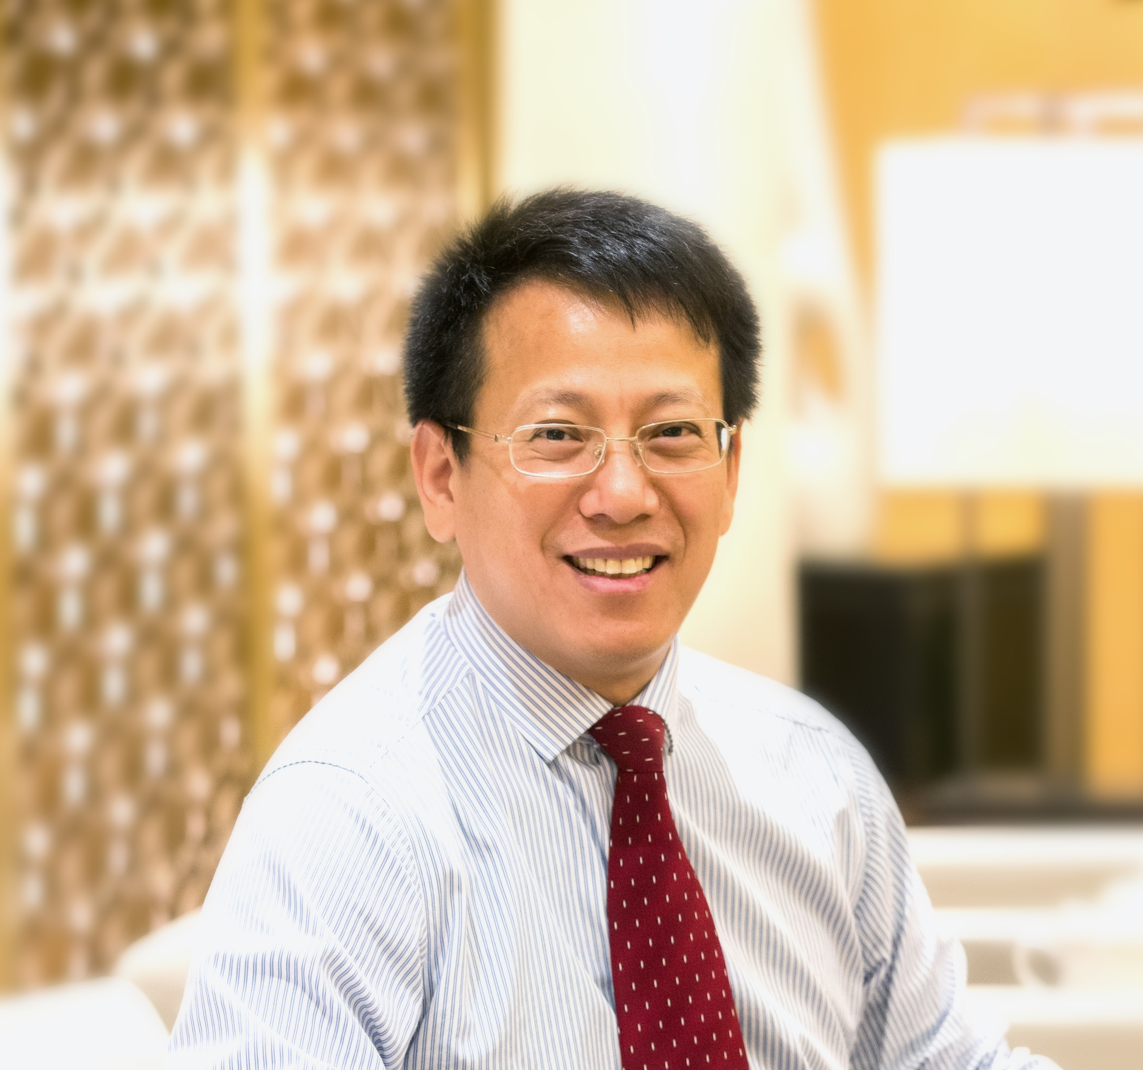
个人简介（中文）：
杨光富：现任华中师范大学教授、博士生导师、校学术委员会副主任、智能生物传感技术与健康国际联合研究中心主任、农药与化学生物学教育部重点实验室主任。1992年毕业于华中师范大学化学系，获理学学士学位；1997年毕业于南开大学，获理学博士学位。2004～2005年赴美国University of Kentucky药学院做高级访问学者。2012年赴加拿大McMaster University化学与化学生物学系做高级访问学者。
长期从事农药及药物分子设计研究，建立了基于活性小分子与作用靶标相互作用研究的生物合理设计创新研究体系，发展了药效团链接碎片虚拟筛选、计算突变扫描等分子设计新方法，成功创制出全球第一个高粱地选择性除草剂喹草酮和进入登记程序的吡唑喹草酯、氟苯醚酰胺、苯醚唑酰胺等多个农药候选新品种，并创制出多个进入临床前研究的抗肿瘤活性候选化合物。先后在PNAS、NC、JACS等国际权威期刊发表SCI论文260多篇，被SCI他引7000多次，获中国发明专利授权45项及欧美发达国家授权专利19项。获教育部自然科学一等奖、湖北省自然科学一等奖、侯德榜科技创新奖、药明康德生命化学研究奖和三农金桥奖各1项。2009年获国家杰出青年科学基金资助，2013年入选国家中青年科技创新领军人才，2016年入选万人计划科技创新领军人才，2020年入选Elsevier“中国高被引学者”榜单。先后被授予全国模范教师、全国优秀科技工作者等荣誉称号。指导博士学位论文获全国百篇优秀博士学位论文奖1项和提名奖2项。
主要学术兼职：教育部科学技术委员会第五、六届化学化工学部委员、国家自然科学基金委员会第十三届化学学科评审组成员、中国化学会农业化学专业委员会副主任委员、中国化学会化学生物学专业委员会委员、中国化工学会农药专业委员会委员、湖北省化学化工学会副理事长、湖北省植物保护学会副理事长、《农药学学报》副主编、《现代农药》副主编、《农药》、《有机化学》编委、Chinese Chemical Letters、Letters in Drug Design & Discovery、Journal of Agricultural and Food Chemistry编委。

个人简介（英文）：
Guang-Fu Yang is now a professor at Central China Normal University (CCNU), vice chairman of the Academic Committee of CCNU, director of the Key Laboratory of the Ministry of Education of Pesticide & Chemical Biology, and director of the International Joint Research Center for Intelligent Biosensing Technology and Health. He graduated from Central China Normal University in 1992, and received his PhD from Nankai University in 1997. He was a senior visiting scholar at College of Pharmacy, University of Kentucky during 2004 to 2005. He was also a short-term visiting professor at McMaster University in August, 2012.
His research interest mainly focuses on structure-based pesticide design. He developed a series of novel methods for pesticide design, and constructed a comprehensively computational platform for pesticide design and chemical biology study. He has invented 6 green pesticides, including benquitrione as the first selective herbicide used for the weed control in sorghum field. He has published more than 260 papers in peer-reviewed journals, such as PNAS, NC, JACS and Angew, and granted over 50 Chinese invention patents and 20 international patents by developed countries. He won the first prize of Natural Science of the Ministry of Education in 2006, the first prize of Natural Science of Hubei Province in 2005, Hou Debang Science and Technology Innovation Award in 2021, and Golden Bridge Award in 2021. He got the National Science Fund for Distinguished Young Scholars in 2009, and was selected as the leading talents of the "10,000 Talents Plan" for scientific and technological innovation in 2016. He was awarded the National Model Teacher and National Excellent Scientific and technological Worker.
He is now the Associate Editor-in-Chief of Chines Journal of Pesticide Science, Associate Editor-in-Chief of the Advanced Pesticide, Editorial Board member of the Pesticide, Chines Journal of Organic Chemistry, Chinese Chemical Letters, Letters in Drug Design & Discovery, and Journal of Agricultural and Food Chemistry.

